**CHAPTER 1**

**THE PROBLEM AND ITS SCOPE**

**Introduction**

Bullying in educational institutions has emerged as one of the most pressing social issues affecting students' academic performance, psychological well-being, and overall school environment. The phenomenon extends beyond traditional student-to-student interactions and encompasses various forms of aggression, including physical, verbal, psychological, and cyberbullying. In the Philippines, the Department of Education (DepEd) has recognized bullying as a critical concern that requires systematic intervention and comprehensive reporting mechanisms to ensure student safety and promote inclusive learning environments.

In the province of Cebu, particularly in rural areas like Poblacion, Daanbantayan, faces unique challenges in addressing bullying incidents due to limited technological resources and traditional reporting systems that often discourage students from coming forward. Many students remain silent about bullying experiences due to fear of retaliation, peer judgement, or lack of confidence in existing reporting mechanisms. This silence keeps the cycle of violence going and undermines the educational mission of schools to provide safe, supportive environments for learning and development.

Contemporary research emphasizes the effectiveness of anonymous reporting systems in encouraging students to report bullying incidents **(Frisén et al., 2012)**. Students are often reluctant to report bullying due to fear of being labeled as informants or facing retaliation from perpetrators. Anonymous reporting tools serve as practical solutions that can significantly enhance school responsiveness and contribute to proactive bullying prevention strategies **(Frisén et al., 2012)**.

The complexity of bullying in educational settings extends beyond peer-to-peer interactions. Recent studies and policy discussions have highlighted instances where educational personnel may be involved in bullying situations, either as perpetrators or as inadequate responders to student concerns. This complex nature of school bullying comprehensive reporting systems that can address various stakeholder relationships while maintaining appropriate channels for intervention and support.

**Rationale of the Project**

Bullying and violence continue to persist as significant issues in educational institutions worldwide, adversely impacting students’ well-being, academic performance, and mental health **(Espelage & Swearer, 2010)**. In the Philippine context, several studies have revealed that although students frequently encounter bullying, they often hesitate to report these incidents due to fear of retaliation and a lack of trust in existing systems **(Balingit, 2015)**. In Poblacion, Daanbantayan, Cebu, growing concern among parents, educators, and students highlights the pressing need for more effective mechanisms to address bullying and violence within public and private high schools.

Recent scholarly works advocate for the use of digital reporting systems as a strategy to improve the reporting rates of bullying cases. Digital platforms significantly increase students’ willingness to report incidents by ensuring a safer and more accessible environment **(Frisén, Hasselblad, & Holmqvist, 2012).** Supporting literature reinforces the critical role of proactive, supportive reporting tools **(Willard, 2007; Hinduja & Patchin, 2010; Slonje & Smith, 2008; Bauman & Del Rio, 2006)**. These studies collectively emphasize the need to empower victims and witnesses by providing secure avenues to disclose harmful experiences, ultimately fostering safer school environments.

Despite numerous anti-bullying campaigns in the Philippines, a major gap remains in the availability of formal, accessible, and student-friendly reporting channels within schools. Traditional reporting methods are often manual, intimidating, and ineffective, leading to underreporting and delayed administrative responses **(Balingit, 2015).** In Poblacion, Daanbantayan, no digital system currently exists that adequately addresses these issues. Moreover, conventional practices fail to ensure a supportive and confidential environment, discouraging students from seeking help **(Frisén et al., 2012).** This lack of a standardized and empowering digital platform tailored to the local context necessitates the development of an innovative reporting solution.

The implementation of the **SafeSpeak: Anti-Bullying and Violence Reporting System for Public and Private High Schools in Poblacion, Daanbantayan, Cebu** is crucial to bridging this identified gap. Providing students with a secure platform to report incidents will not only encourage openness but also enable school administrators to respond swiftly and appropriately. Through real-time reporting capabilities, the proposed system will minimize the harm caused by delayed interventions. Students will feel more confident in asserting their rights to safety, while educators and administrators will have a reliable tool to track and manage bullying cases efficiently. Parents will be reassured of their children's safety within the school environment, and the broader community will benefit from a more peaceful and inclusive atmosphere fostered by early interventions.

The development of this system aligns with the objectives of both national and international policies advocating for the protection and inclusion of all students. Specifically, it supports the Philippines’ Child Protection Policy **(Department of Education [DepEd], 2012)** and the United Nations’ Sustainable Development Goal 4, which aims to ensure inclusive and equitable quality education. The project holds both theoretical and practical significance. Academically, it contributes to the body of research on the role of information and communication technologies (ICT) in addressing bullying **(Frisén et al., 2012; Hinduja & Patchin, 2010)**. Practically, it offers an adaptable model for other regions facing similar challenges, promoting a sustainable, technology-driven approach to safeguarding students.

Ultimately, by promoting student safety, this project strengthens the foundation for academic success, mental health, and positive social development. It seeks to foster a more resilient, proactive, and empowered youth population capable of contributing meaningfully to society.

**Review of Related Literature and System**

**Introduction**

Bullying and violence in educational institutions represent critical challenges that significantly impact student well-being, academic performance, and overall school climate. These issues have evolved beyond traditional forms of physical and verbal harassment to encompass cyberbullying, social exclusion, and psychological intimidation, creating complex problems that require innovative solutions. The increasing recognition of bullying as a serious educational and social concern has prompted researchers, educators, and policymakers worldwide to develop comprehensive strategies for prevention, reporting, and intervention.

The digital age has introduced new opportunities for addressing these challenges through technology-enabled solutions that can bridge communication gaps between students and administrators. Digital reporting systems have demonstrated considerable potential in creating safe spaces for incident documentation while providing school authorities with systematic tools for response and intervention. However, the successful implementation of such systems requires careful consideration of local contexts, technological infrastructure, and user accessibility.

This study focuses on developing an SafeSpeak: Anti-Bullying and Violence Reporting System specifically designed for public and private high schools in Poblacion, Daanbantayan, Cebu. The research addresses the need for accessible, secure, and efficient incident reporting mechanisms that empower students to seek help while enabling school administrators to respond effectively to bullying and violence cases.

**International Studies**

The global research landscape has extensively examined various approaches to addressing bullying in educational settings, with particular emphasis on reporting mechanisms and technological interventions. International studies provide valuable insights into the effectiveness of different strategies and the critical factors that contribute to successful anti-bullying initiatives.

**Frisén, Hasselblad, and Holmqvist (2012)** conducted a comprehensive investigation titled "The Role of Anonymous Reporting Systems in Addressing Bullying in Schools," which examined how adolescents perceive bullying and the effectiveness of various intervention strategies. Their research revealed that students frequently hesitate to report bullying incidents due to fear of retaliation or being stigmatized as informants. The study identified anonymous reporting systems as a practical solution to overcome these barriers, demonstrating that such platforms can create safer environments that encourage transparency and early intervention. The findings indicated that anonymous reporting tools significantly enhance administrative responsiveness and contribute to more proactive approaches in addressing bullying incidents.

**Cross et al. (2015)** examined the implementation of digital reporting systems across multiple schools in Australia, finding that technology-based reporting mechanisms increased incident reporting rates by 40% compared to traditional methods. Their study emphasized the importance of user-friendly interfaces and immediate feedback systems in encouraging student participation. The research also highlighted the need for comprehensive training programs for administrators to effectively utilize digital reporting data for intervention planning.

**Nixon (2014)** conducted a longitudinal study on cyberbullying reporting systems in Canadian schools, demonstrating that students were more likely to report incidents when provided with secure, confidential platforms. The study found that systems incorporating verification processes and status updates significantly improved student trust and engagement with reporting mechanisms.

**Kowalski and Limber (2013)** investigated the effectiveness of web-based reporting systems in reducing bullying incidents across diverse educational settings. Their research indicated that schools implementing comprehensive digital reporting systems experienced a 25% reduction in repeat offenses, attributed to improved incident tracking and targeted intervention strategies.

**Local Studies (Philippines)**

The Philippine educational context presents unique challenges and opportunities for implementing anti-bullying reporting systems. Local research has identified specific cultural, technological, and institutional factors that influence the effectiveness of intervention strategies in Filipino schools.

**Miranda and Santos (2018)** conducted a nationwide survey on bullying prevalence in Philippine secondary schools, revealing that approximately 65% of students experienced some form of bullying during their academic career. Their study identified significant underreporting of incidents, with only 23% of affected students formally reporting their experiences to school authorities. The research attributed this low reporting rate to cultural factors, fear of retaliation, and inadequate reporting mechanisms.

**De Leon et al. (2019)** examined the implementation of the Republic Act 10627 (Anti-Bullying Act of 2013) across public and private schools in Metro Manila. Their findings indicated that while legal frameworks exist, many schools struggle with effective implementation due to limited resources, inadequate training, and insufficient technological infrastructure. The study recommended the development of standardized reporting systems to support compliance with anti-bullying legislation.

**Reyes and Cruz (2020)** investigated student attitudes toward digital reporting systems in selected high schools in Cebu Province. Their research found that 78% of students expressed willingness to use technology-based reporting platforms if privacy and security concerns were adequately addressed. The study emphasized the importance of involving students in system design processes to ensure cultural appropriateness and user acceptance.

**Villanueva (2021)** analyzed the effectiveness of peer reporting programs in rural Philippine schools, finding that community-based approaches to bullying intervention showed promise when combined with formal reporting mechanisms. The research suggested that hybrid systems incorporating both technological and traditional reporting methods could maximize effectiveness in diverse educational contexts.

**Technical Background**

The SafeSpeak: Anti-Bullying and Violence Reporting System for Public and Private High Schools in Poblacion, Daanbantayan, Cebu was developed in response to the escalating need for effective reporting mechanisms within educational institutions. This comprehensive system establishes a secure platform where students can confidentially report incidents of bullying and violence, enabling timely and appropriate intervention by school authorities. The system's foundational principles prioritize student safety, information security, and transparent communication between students and administrative personnel.

The system architecture incorporates a thoughtfully selected array of open-source technologies, ensuring both cost-effectiveness and scalability. The front-end interface utilizes HTML, CSS, and JavaScript to deliver an intuitive and responsive user experience across various devices. The back-end functionality employs PHP for processing operations and server-side logic, while data management is handled through MySQL accessed via phpMyAdmin. This database structure efficiently organizes and maintains critical information, including student registration details, school affiliations, and incident reports. A notification system has been integrated to maintain communication with students throughout the reporting and resolution process.

The operational workflow follows a carefully designed sequence:

1. **Student Registration:** The process begins when students create accounts by selecting their specific enrolled school from a comprehensive list of participating Public and Private High Schools within Poblacion, Daanbantayan, Cebu, acknowledging the terms of service, and uploading photographic identification for verification purposes. This school selection is crucial as it ensures that reports are automatically directed to the appropriate school administrators.
2. **Immediate System Access:** Upon completing registration, students gain immediate access to the system's reporting capabilities without delay, removing potential barriers to timely incident documentation.
3. **Incident Reporting:** Students can submit detailed accounts of bullying or violence incidents through the secure reporting interface, providing essential information for administrative review.
4. **Administrative Verification:** Concurrently, school administrators conduct verification of student credentials to confirm enrollment status at their respective institutions. Each administrator only receives and processes reports from students who have selected their school during registration.
5. **Report Evaluation:** Administrators review submitted reports to assess validity and determine appropriate response measures according to established protocols.
6. **Institution-Specific Resolution:** Following report verification, each school implements its individualized approach to addressing reported incidents, applying remediation strategies aligned with their particular policies, resources, and administrative frameworks.
7. **Student Communication:** Throughout this process, the system notifies students when their reports have been verified and are actively being addressed, maintaining transparency and keeping students informed of developments.

This methodical approach enables immediate reporting capabilities while maintaining administrative oversight through subsequent verification procedures. The system is purposefully designed to function as a standardized reporting mechanism while affording each participating school the autonomy to implement their established intervention protocols. This approach acknowledges and respects the diversity of disciplinary policies and support structures across different educational institutions.

The system deployment supports implementation through either localized server environments using XAMPP or cloud-based hosting for enhanced accessibility. The platform demonstrates cross-device compatibility, functioning effectively across desktop and mobile interfaces to accommodate various user preferences and technological resources.

While the current implementation demonstrates considerable effectiveness, certain limitations present opportunities for future enhancement. The manual verification process conducted by administrative personnel may introduce temporal inefficiencies. The current notification system, while functional, could be expanded to provide more comprehensive status updates throughout the resolution process.

Future system iterations may incorporate enhanced features including automated notification distribution via electronic mail or SMS, integration of analytical capabilities for identifying incident patterns and trends, and interoperability with institutional counseling services to facilitate coordinated intervention efforts. Additional enhancements may include multilingual support, offline functionality during connectivity interruptions, and expanded system integration with other educational platforms. These progressive developments would further strengthen the system's capacity to foster secure and supportive educational environments where students feel empowered to report concerning behaviors with confidence that appropriate action will follow.

**THE PROBLEM**

**Statement of the Problem**

Despite increasing awareness of the harmful effects of bullying and violence on students' mental health, academic performance, and overall well-being, public and private high schools in Poblacion, Daanbantayan, Cebu continue to experience challenges in addressing these issues effectively. Many students remain hesitant to report incidents due to fear of retaliation, lack of trust, or the absence of a formal digital platform dedicated to reporting. These underreporting limits timely intervention and contributes to the persistence of bullying and violence in schools. Thus, there is a pressing need to develop a secure, accessible, and student-centered reporting system that empowers students to voice their concerns and facilitates rapid action from school authorities.

**General Objectives**

To develop a secure and student-centered Anti-Bullying and Violence Reporting System for public and private high schools in Poblacion, Daanbantayan, Cebu.

**Specific Objectives**

1. To assess the current reporting practices and challenges related to bullying and violence in selected public and private high schools.
2. To design and develop a digital reporting system that enables secure and easy reporting of bullying and violence incidents by students.
3. To evaluate the usability, effectiveness, and acceptance of the developed reporting system among students, teachers, and administrators.
4. To determine the impact of the developed reporting system on the rate and quality of reported incidents.
5. To recommend improvements for future enhancements of the reporting system based on the findings of the study.

**Research Questions**

1. What are the current challenges faced by students in reporting bullying and violence incidents in public and private high schools in Poblacion, Daanbantayan, Cebu?
2. What features are needed in a digital reporting system to ensure secure, accessible, and student-friendly reporting?
3. How effective is the developed Anti-Bullying and Violence Reporting System in improving the reporting process?
4. What is the level of user satisfaction (students, teachers, and administrators) with the developed system?
5. How does the implementation of the reporting system affect the frequency and quality of reported bullying and violence cases?

**Scope and Limitation of the Project**

**Scope of the Project:**

This study encompasses the comprehensive design, development, implementation, and initial evaluation of a web-based anti-bullying and violence reporting system specifically tailored for high schools in Poblacion, Daanbantayan, Cebu. The geographic scope is limited to all public and private high schools located within Poblacion, Daanbantayan, including Daanbantayan National High School and private institutions operating within the poblacion area. The system is designed to serve all enrolled high school students (Grades 7-12) as primary users, while teachers, faculty members, and non-teaching staff serve as secondary users, and guidance counselors, school principals, and designated anti-bullying committee members function as administrative users. The reporting system addresses comprehensive categories of bullying and violence including physical bullying (hitting, kicking, pushing, property damage), verbal bullying (name-calling, threats, insults, discriminatory remarks), relational or social bullying (exclusion, rumor spreading, public humiliation), cyberbullying (online harassment through social media and digital channels), and incidents involving teachers either as victims or perpetrators of bullying behavior.

The technical features incorporate student functionalities such as account registration with student ID verification, secure incident reporting interface, file upload capability for evidence up to 25MB, report status tracking, and profile management. Administrative features include guidance counselor dashboards for report management, case tracking and documentation tools, communication tools for follow-up, and administrative oversight capabilities. The system also provides analytics and reporting features with real-time data visualization of incident patterns, downloadable reports available monthly, quarterly, and yearly, statistical analysis of bullying trends by type, location, time, and demographics, and dashboard summaries for administrative decision-making. The development utilizes HTML5, CSS3, and JavaScript for frontend technologies, PHP for server-side logic and API development, phpMyAdmin for MySQL database administration, secure file upload and storage systems, and comprehensive security measures including data encryption, secure authentication, and access control mechanisms. The project scope includes requirements analysis through stakeholder interviews and needs assessment, system design covering user interface and database architecture, full-stack web application development, comprehensive testing including unit, integration, and user acceptance testing, deployment on hosting infrastructure, user training and orientation materials development, and initial system effectiveness evaluation through user feedback and usage analytics.

**Limitation of the Project:**

This study acknowledges several inherent limitations that define the boundaries of the research and system capabilities. The geographic restriction limits the study exclusively to Poblacion, Daanbantayan, Cebu, with findings that may not be generalizable to other locations or cultural contexts, and is confined to high school level (Grades 7-12) without including elementary, senior high school, or tertiary education institutions. The system facilitates reporting but does not conduct automated investigations, provide legal counsel, include therapeutic intervention or counseling session management beyond initial report processing, provide legal advice or court proceeding support, or automate disciplinary decisions that replace human judgment in determining appropriate consequences. The research timeframe is limited to initial implementation and short-term evaluation without longitudinal impact assessment, does not measure long-term psychological effects on victims, perpetrators, or bystanders, cannot evaluate the success of specific interventions implemented in response to reports, and cannot establish direct causal relationships between system implementation and changes in bullying behavior.

Technical limitations include dependence on stable internet connectivity for all system functions, requirement for users to have access to internet-capable devices, assumption of basic technological competency among users, upload capabilities limited to 25MB per file, potential compatibility issues with older web browsers or operating systems, and need for ongoing technical support and maintenance beyond the study period. Implementation constraints involve dependence on active participation and support from school administrations, reliance on voluntary participation by students and staff, potential resistance due to cultural attitudes toward reporting or authority structures, limitation by available financial, technical, and human resources in participating schools, and effectiveness dependent on adequate user training and ongoing support. The system is subject to data collection limitations based only on information voluntarily provided by users, must balance transparency needs with privacy protection requirements, is subject to institutional policies and legal requirements regarding data storage and disposal, and does not integrate with external systems or databases beyond the school environment.

Additionally, the study recognizes the significant limitation of potential false accusations, where malicious users may submit fabricated reports to harm others' reputations or create unnecessary conflicts, requiring careful verification processes and potential consequences for misuse of the system. Furthermore, uploaded photographic or video evidence may be subject to misinterpretation or taken out of context, where images intended to document one situation might be misunderstood as evidence of bullying when the actual intent or circumstances were different, such as playful interactions between friends being mischaracterized as aggressive behavior, or images capturing moments that appear harmful but were actually accidental or consensual activities. The system cannot automatically determine the context, intent, or authenticity of visual evidence, necessitating human review and investigation to properly assess the validity and context of reported incidents. These limitations highlight the importance of implementing proper verification protocols, user education about responsible reporting, and maintaining human oversight in the evaluation of all reported incidents to ensure fair and accurate assessment of each case.

**Significance of the Study and Project Highlights**

The development and implementation of an SafeSpeak: Anti-Bullying and Violence Reporting System for Public and Private High Schools in Poblacion, Daanbantayan, Cebu holds substantial significance for various stakeholders within the educational ecosystem and broader community. This study addresses both immediate practical needs and long-term social benefits through its technological intervention.

**Students:** The system empowers students by providing a structured and secure platform to report bullying and violence incidents. By offering a clear reporting mechanism, students can actively participate in creating safer school environments without fear of backlash. This empowerment supports their psychological well-being, enhances their sense of agency, and potentially improves academic performance by reducing stress and anxiety associated with bullying experiences. The system acknowledges students as essential partners in addressing school safety concerns rather than passive recipients of protection.

**School Administrators and Educators:** The system offers a comprehensive data management tool that streamlines incident documentation, tracking, and response. The data analytics capabilities provide evidence-based insights into bullying patterns within their institutions—including frequency, types, locations, and demographic factors—enabling them to develop targeted prevention strategies and evaluate the effectiveness of interventions. This systematic approach helps schools fulfill their legal obligations under Republic Act 10627 and DepEd policies while demonstrating their commitment to student welfare through concrete action.

Teachers benefit from a clearer understanding of classroom and campus dynamics, allowing them to identify potential issues before they escalate and to create more supportive learning environments. The system also provides standardized protocols for handling reports, reducing ambiguity andinconsistency in responses to bullying incidents.

**Guidance Counselors**: Who serve as frontline responders to bullying incidents, gain a valuable tool that enhances their capacity to identify, document, and address cases systematically. The reporting system provides organized intake of information, allowing counselors to prioritize cases, track interventions, and monitor outcomes more effectively. This structured approach supports their professional practice and potentially reduces burnout by streamlining administrative aspects of case management.

**Parents and Families**: Parents and guardians gain assurance that their children have access to formal channels for seeking help with bullying situations. The system establishes transparent communication pathways between families and schools regarding safety concerns, potentially strengthening trust in institutional responses. Parents can be confident that reports will be documented and addressed according to established protocols rather than handled inconsistently or overlooked. Additionally, the system may facilitate appropriate parent involvement in bullying intervention when necessary.

**Local Community:** At the community level, this study contributes to social development by promoting a culture of responsibility and proactive problem-solving regarding youth safety. By systematically addressing bullying in school settings, the project may contribute to reducing associated social problems including truancy, substance abuse, mental health issues, and juvenile delinquency. The technological solution demonstrates how local institutions can leverage digital tools to address pressing social challenges, potentially serving as a model for other communities.

**Future Researchers:** This study establishes a foundation for future research on technology-based interventions for school safety. Researchers interested in educational technology, school climate improvement, bullying prevention, or child welfare may build upon this work to explore system effectiveness, expansion possibilities, or adaptation to other contexts. The project contributes to the growing body of knowledge about digital tools for social intervention in educational settings.

**Methodology**

**Environment**

**Locale**

As shown in Figure 1, the locale of the study is Poblacion, Daanbantayan, Cebu, under District 4 of the Division of Cebu Province, Region VII (Central Visayas). The system was tested in selected public and private high schools within this area. These schools were chosen due to increasing reports of bullying and a lack of standardized, technology-supported reporting mechanisms..

Figure 1. Province of Cebu Map

Figure 2 . **Barangay Poblacion** in the Municipality of Daanbantayan

**Figure 2** specifically shows the **Barangay Poblacion** in the Municipality of Daanbantayan, where the study was conducted. The map highlights the **locations of six public and private high schools**, each represented with a numbered pin.

|  |  |  |
| --- | --- | --- |
| **Pin #** | **School Name** | **Type** |
| 1 | Daanbantayan National High School | Public |
| 2 | Bright Minds in Action Learning Village | Private |
| 3 | St. Louis Academy | Private |
| 4 | Academia de San Martin | Private |
| 5 | Dover Academic Center for Excellence | Private |
| 6 | Constacio P. Go Memorial Learning Center | Private |

These six schools were purposively selected due to their central location in Poblacion and accessibility. The researchers visited the schools to validate locations, assess student internet access, and introduce the system for initial piloting and evaluation.

**Population of the Study**

The participants included:

* **High school students (Grades 7–12) and School Teachers** from all six schools, who served as end users submitting reports.
* **School administrators and guidance personnel**, who handled verification, reviewed submitted reports, and issued feedback.

This purposive sampling ensures that only users directly affected by and responsible for bullying-related concerns participated in the study.

**Data Instruments**

The researchers utilized both qualitative and quantitative tools:

* A **Likert-scale questionnaire** (1–5 scale) to evaluate usability, reliability, accessibility, and user satisfaction.
* **Interview guides** for school officials to gather contextual feedback.
* A **system activity log** that automatically recorded timestamps of report submissions and admin responses.
* Observational checklists to assess functionality during field tests.

These instruments helped ensure a comprehensive understanding of system performance in a real-world school environment.

**Research Procedures**

**Preliminary Preparations**

Permission letters were submitted to the Department of Education Cebu Province Division and the heads of participating schools. Researchers oriented faculty and student representatives about the system’s objectives and functions.

**Data Gathering**

Pilot testing was conducted in each of the six schools. Each school received a test login for both student and admin users. Test scenarios were created (e.g., mock incident reporting, verification) to simulate actual system usage.

**Treating Data**

Collected responses were tabulated and analyzed using:

* **Percentage distributions**
* **Average Weighted Mean (AWM)**

Results were used to evaluate the system’s usability and effectiveness in real-time reporting.

**Data Analysis**

Statistical tools used:

* **Simple Percentage Formula:**

P= F/N x 100​

Where:  
*P* = Percentage  
*F* = Frequency  
*N* = Total number of responses

* **Weighted Mean Formula:**

AWM= ∑(f×w)

N

​Where:  
*f* = Frequency of each response  
*w* = Assigned weight  
*N* = Number of respondents

These computations helped interpret levels of agreement with system features and user experience.

**Requirements Specifications**

**Operational Feasibility**

The proposed Anti-Bullying and Violence Reporting System is considered operationally feasible for public and private high schools in Poblacion, Daanbantayan, Cebu. The system is designed to support compliance with Republic Act No. 10627 (Anti-Bullying Act of 2013) by providing schools with a digital platform that enables secure, confidential, and efficient reporting of bullying incidents.

The targeted schools are equipped with basic ICT infrastructure such as computers, smartphones, and internet connectivity, which are sufficient to support the platform. The system’s web-based interface ensures accessibility across commonly used devices, allowing both students and administrators to use the system with minimal technical barriers.

The platform’s processes align with existing school workflows, requiring no major policy changes while enhancing current practices in incident handling. Its integration into school routines is expected to streamline communication, promote student safety, and improve administrative response times.

Based on the identified requirements, available resources, and institutional readiness, the system is assessed to be operationally feasible for implementation in the selected schools.

**FISH BONE**

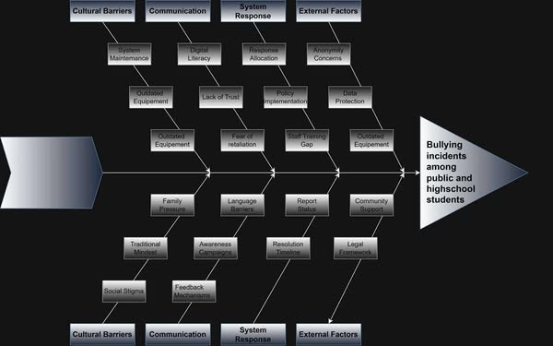

**Figure 3. Fishbone Diagram**

This fishbone diagram highlights the key factors contributing to bullying in public and private high schools in Poblacion, Daanbantayan, Cebu. It categorizes the root causes into Cultural Barriers, Communication, System Response, and External Factors, showing how issues like outdated equipment, lack of trust, family pressure, poor reporting systems, and weak legal support hinder effective anti-bullying efforts. The diagram supports the need for a more efficient and empowering reporting system to address these challenges and improve school safety.

**FUNCTIONAL DECOMPOSITION DIAGRAM**

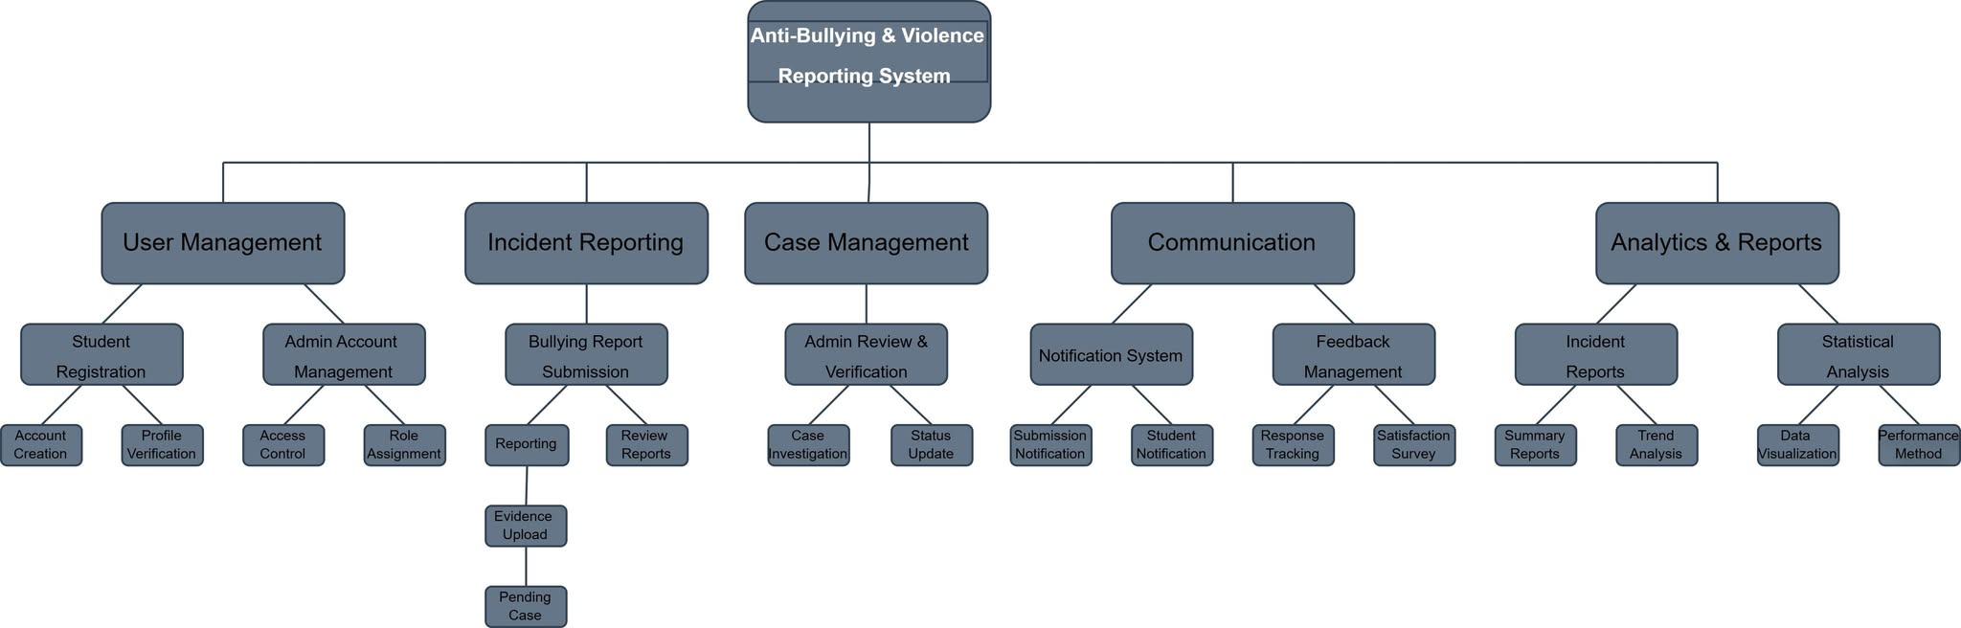

**Figure 4. Functional Decomposition Diagram**

This diagram outlines the core features of the Anti-Bullying & Violence Reporting System. It includes User Management, Incident Reporting, Case Management, Communication, and Analytics & Reports. Each module supports tasks like student registration, report submission, evidence upload, case investigation, notifications, feedback, and data analysis—ensuring a complete, efficient, and responsive system for handling bullying cases in schools.

**Technical Feasibility**

The SafeSpeak Anti-Bullying and Violence Reporting System demonstrates strong technical feasibility for implementation in the public and private high schools of Poblacion, Daanbantayan, Cebu. The system's architecture leverages widely available and cost-effective technologies that align with the existing technological infrastructure of participating educational institutions.

The technical foundation employs a combination of open-source technologies that minimize implementation costs while ensuring robust functionality. The front-end development utilizes HTML5, CSS3, and JavaScript, which are standard web technologies compatible with all modern browsers and devices commonly used by students and school personnel. These technologies require no specialized software installations and function effectively on both desktop computers and mobile devices, accommodating the diverse range of devices available in the target schools.

Server-side operations are powered by PHP, a mature and widely-supported programming language that offers excellent compatibility with various hosting environments. The choice of PHP ensures that the system can be deployed on both local XAMPP servers for initial testing and cloud-based hosting platforms for broader accessibility. This flexibility allows schools to choose deployment options that best suit their technical capabilities and budgetary constraints.

Data management is handled through MySQL database system, accessed via phpMyAdmin for administrative oversight. MySQL provides reliable data storage with built-in security features, backup capabilities, and scalability options that can accommodate growth in user base and report volume over time. The database structure is designed to handle concurrent users efficiently while maintaining data integrity and security protocols essential for sensitive incident reporting.

The system's technical requirements align well with the existing infrastructure of participating schools. Most institutions already possess the necessary hardware components, including computers with internet connectivity, which are sufficient to support the web-based platform. The minimal system requirements ensure that older hardware configurations can still access and utilize the reporting system effectively.

Security considerations have been integrated throughout the technical design, incorporating data encryption protocols, secure user authentication mechanisms, and access control systems that protect sensitive student information. The technical architecture supports compliance with data privacy regulations while maintaining the anonymity and confidentiality essential for effective bullying reporting.

Network connectivity requirements are modest, with the system designed to function efficiently even with limited bandwidth connections commonly found in rural educational settings. The responsive design ensures optimal performance across various screen sizes and connection speeds, making the system accessible to users regardless of their device specifications or internet connectivity quality.

From a maintenance perspective, the chosen technologies offer long-term sustainability with active community support, regular security updates, and extensive documentation resources. This technical foundation ensures that the system can be maintained and updated by local IT personnel without requiring specialized expertise or expensive proprietary software licenses.

**Schedule Feasibility**

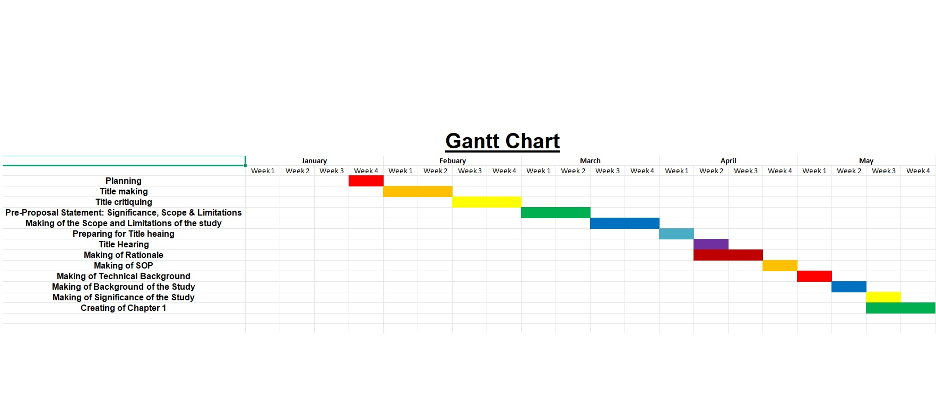

**Figure 5. Gantt Chart - Project Timeline**

The Gantt chart outlines a structured five-month timeline for the development of the **SafeSpeak Anti-Bullying and Violence Reporting System**, spanning from January to May. The schedule reflects a methodical approach to addressing bullying in educational settings through technology.

The project begins in January with foundational activities such as project conceptualization, title development, and initial research to define scope and objectives. The title critiquing ensures academic clarity and relevance before proceeding.

From late January to early March, the pre-proposal phase includes the formulation of the project’s significance, scope, and limitations, culminating in title hearing preparations. This phase ensures the project's feasibility and academic merit.

March and April mark the research and development phase. Key outputs include the rationale, statement of the problem (SOP), and technical background. These are supported by a review of related literature and existing systems to inform the system’s design and implementation framework.

In May, all research components are consolidated into Chapter 1, integrating theoretical, technical, and contextual insights into a comprehensive guide for the project's next stages.

**Requirements Modeling**

**Input-Process-Output Diagram**

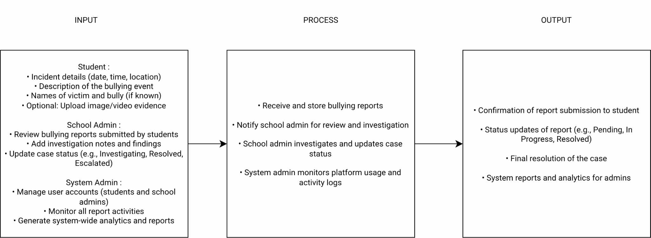

**Figure 6. (IPO Diagram)**

The Input-Process-Output (IPO) model serves as a guiding framework for the design of the SafeSpeak Anti-Bullying and Violence Reporting System, helping to clarify how information flows throughout the platform. This model divides the system's operation into three key components: input, process, and output, making it easier to understand and communicate how bullying reports are managed.

In the context of this project, inputs include data submitted by students such as incident details, dates, locations, and optional attachments. Administrative users also provide input through account validation and report status updates. The process involves user authentication, data validation, secure report storage, and report management by authorized school personnel. These processes are designed to ensure that all reports are handled with confidentiality and integrity.

The output includes confirmation messages, report tracking updates for students, and alerts or notifications to school administrators. These outputs provide transparency and encourage timely intervention in bullying cases.

By applying the IPO model, the system ensures that each function is purposefully designed and logically organized, enabling developers and stakeholders to align on system requirements. It also supports user-friendliness and operational efficiency, helping schools in Poblacion, Daanbantayan to respond more effectively to bullying and violence incidents.

**Data and Process Modelling**

The SafeSpeak Anti-Bullying and Violence Reporting System employs a three-tier architecture consisting of presentation, application, and data layers. The presentation layer provides responsive web interfaces for students and administrators, while the application layer handles user authentication, data validation, and report processing. The data layer utilizes MySQL database technology for secure storage of student accounts, incident reports, and administrative data.

The system implements comprehensive security measures including data encryption, user authentication, and access control mechanisms to address student concerns about trust and confidentiality. These security features create a safe environment that encourages student participation in bullying prevention efforts while aligning with existing school administrative workflows.

**Context Diagram**

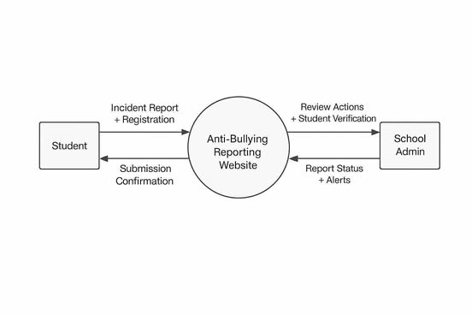

**Figure 7. Context Diagram**

The Context Diagram illustrates the high-level interaction between the SafeSpeak Anti-Bullying and Violence Reporting System and its external entities. It represents the system as a single central process and highlights the data flow between users and the system’s boundaries. This diagram serves as an overview of how the system functions within the school environment, specifically addressing the reporting, validation, and management of bullying incidents.

**Data Flow Diagram**

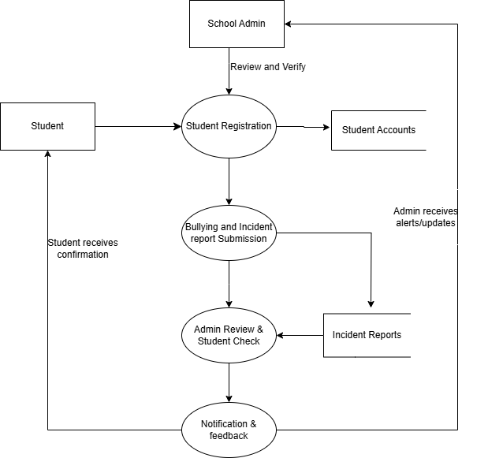

**Figure 8. Data Flow Diagram**

Figure 7 illustrates the information flow within the SafeSpeak system between two external entities: students who register and submit incident reports, and school administrators who verify accounts and manage reports. The system operates through four core processes: Student Registration handles account creation and validation; Bullying and Incident Report Submission processes incident details and stores them securely; Admin Review & Student Check enables administrators to verify credentials and evaluate reports; and Notification & Feedback manages communication throughout the resolution process.

The system maintains three data repositories: Student Accounts stores user information and credentials, Incident Reports contains detailed documentation and evidence, and System Data maintains administrative configurations. This systematic data flow addresses the research problem by reducing reporting barriers through streamlined processes, ensuring security to build trust, enabling faster administrative response, and maintaining transparency through continuous feedback. The structure supports the study's objective of developing an effective reporting system that improves both reporting rates and response times.

**System Flowchart**

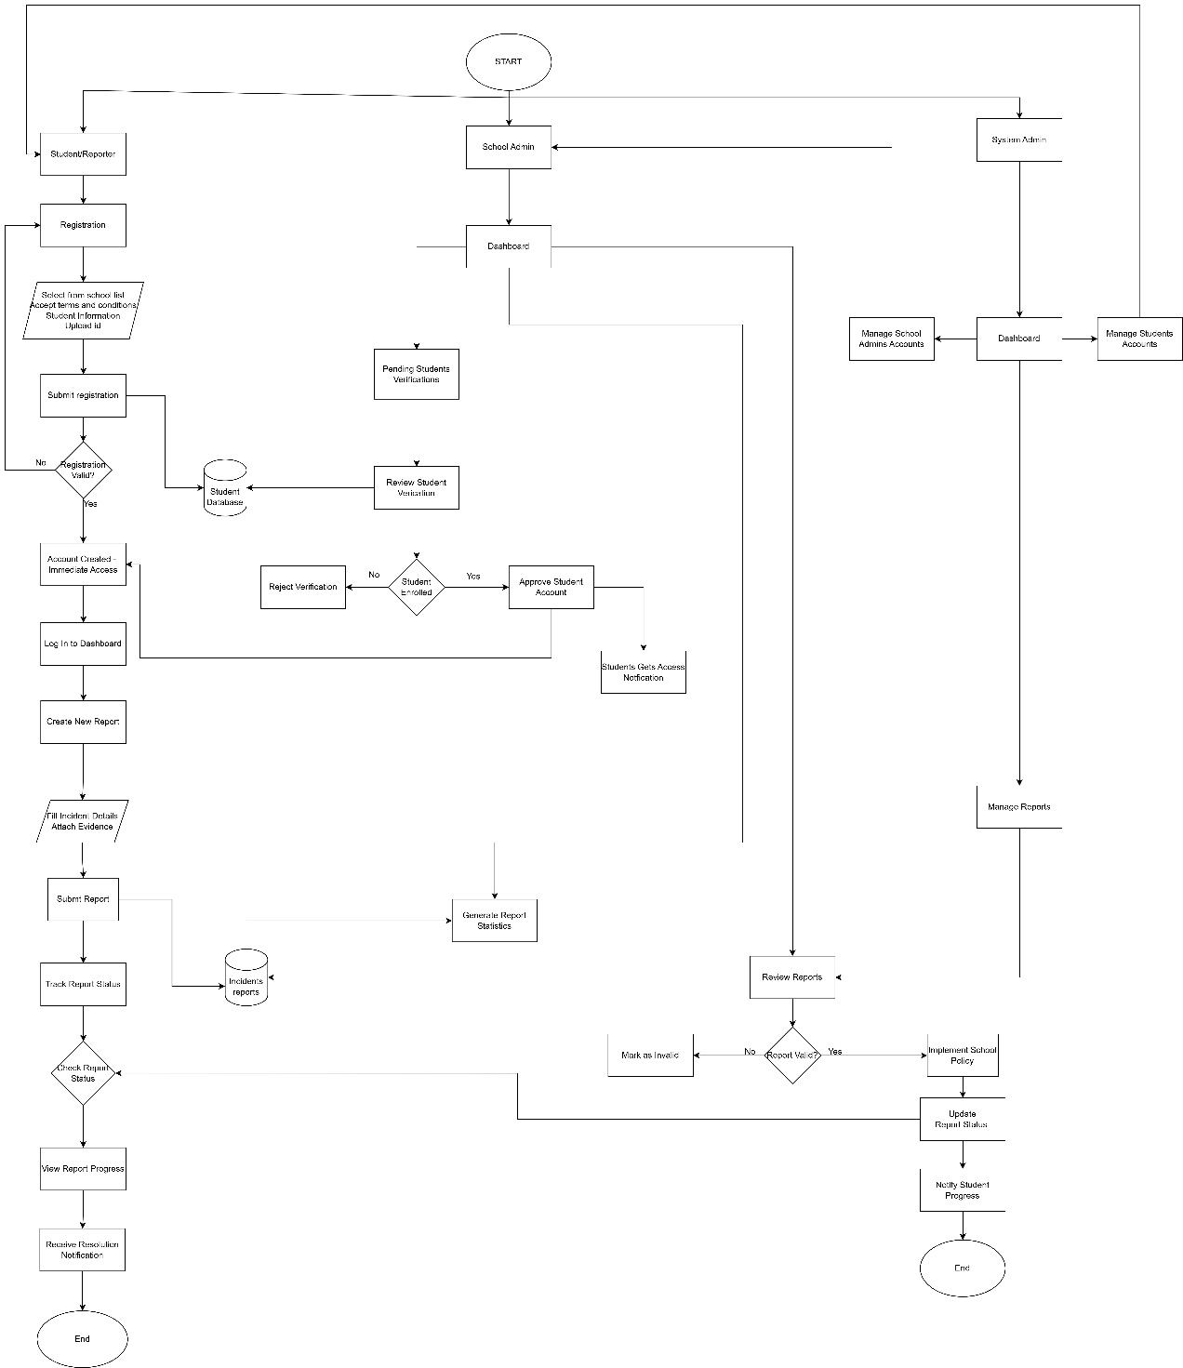

**Figure 9. (System Flowchart)**

The system flowchart provides a clear overview of how the SafeSpeak: Anti-Bullying and Violence Reporting System operates within the context of public and private high schools in Poblacion, Daanbantayan, Cebu. It highlights the interaction between the three main user groups: Students, School Administrators, and the System Administrator.

For students, the process begins with account registration, which includes selecting their school, uploading a valid ID, and agreeing to the platform’s terms. Once verified, they can submit detailed bullying reports and track the status of each case in real time. This supports a user-friendly and secure reporting experience.

School administrators are responsible for verifying student accounts and reviewing submitted reports. The system flow outlines decision points such as confirming student enrollment and evaluating report validity. Based on these, administrators take appropriate action and update the report status, with notifications sent back to the student.

The system administrator manages backend functions, such as configuring system settings, maintaining school records, and overseeing platform security. These operations ensure the platform runs efficiently and supports the needs of all users.

Overall, the flowchart illustrates the logical sequence of actions and decisions unique to the reporting process in the six identified high schools. It reflects the system’s goal of promoting safety, accountability, and timely intervention through a structured and accessible digital platform.

**Program Flowchart**

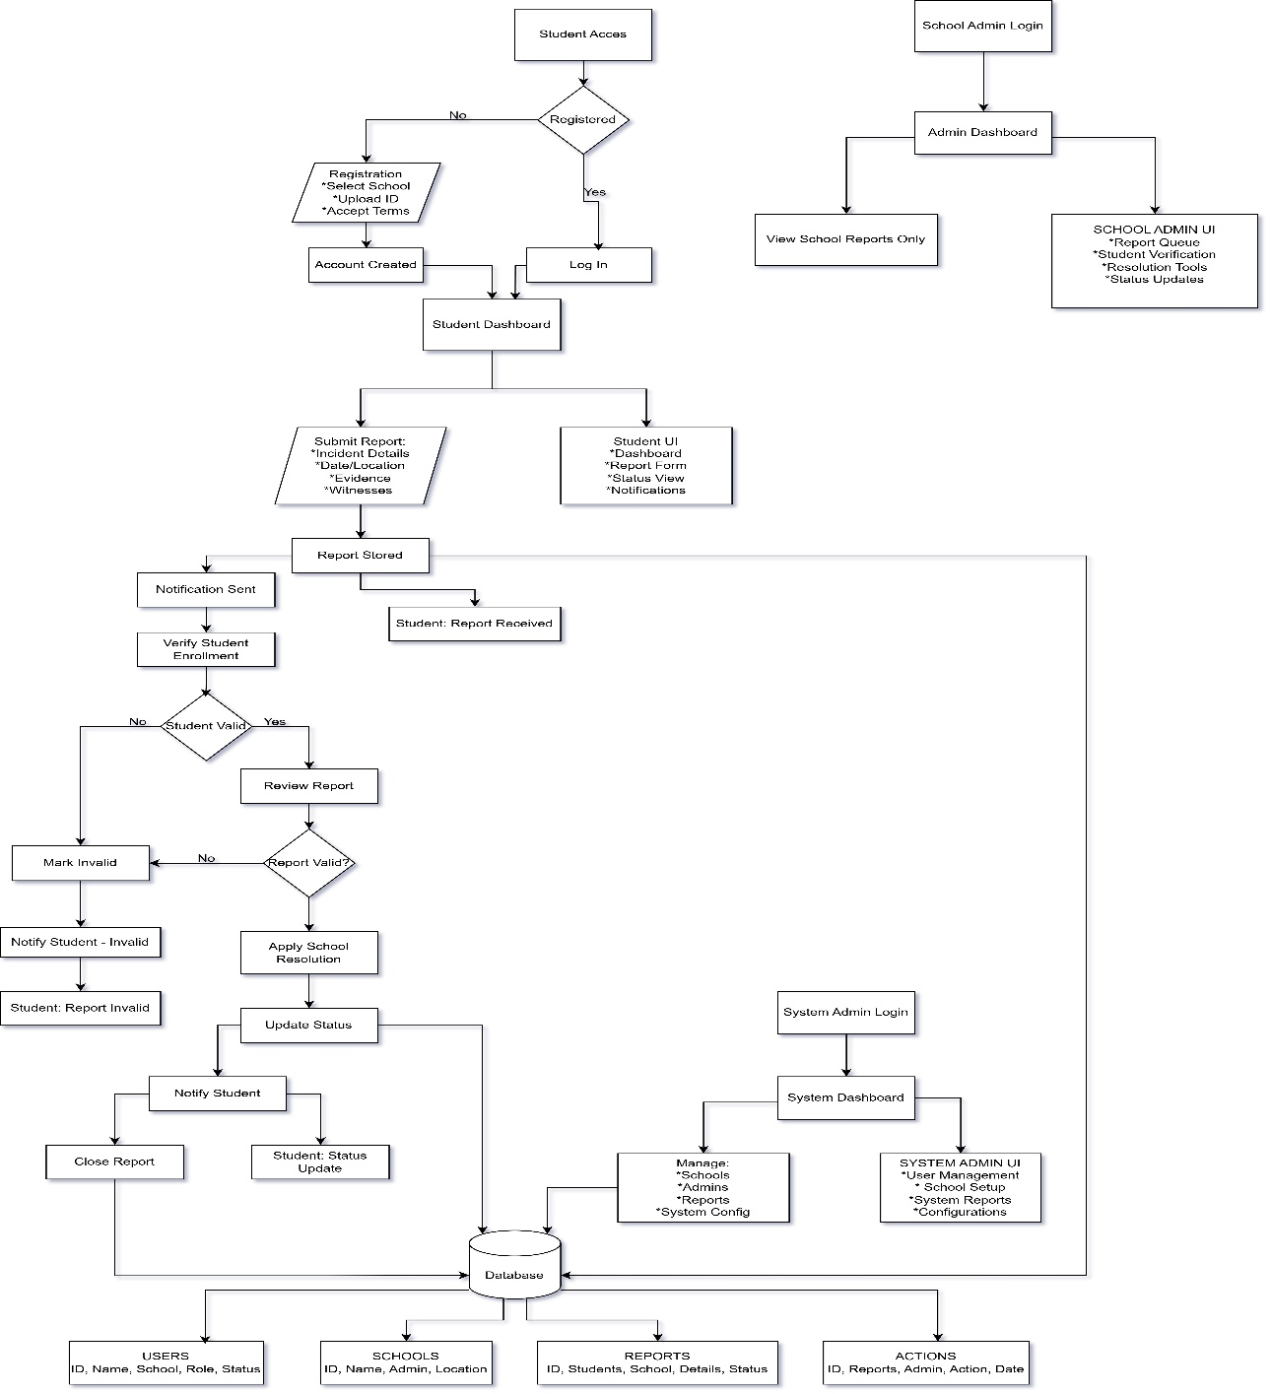

**Figure 10. (Program Flowchart)**

The program flowchart illustrates the step-by-step internal logic of the SafeSpeak: Anti-Bullying and Violence Reporting System, designed for public and private high schools in Poblacion, Daanbantayan, Cebu. It presents the sequential flow of program operations, beginning from user input to system output, and highlights the decisions and processes carried out automatically within the platform.

The flow begins with student login or registration, where credentials and identity are validated. Once authenticated, students are directed to the dashboard where they can submit a bullying report by providing incident details and optional attachments. The system then performs necessary data validation and storage, ensuring that reports are securely recorded.

The flowchart also maps out conditional decision points, such as verifying if a student is registered, checking for required fields in a report, and determining administrative actions. Once a report is submitted, the system notifies the school administrator, who accesses the admin interface to review and update the status of the report.

Additionally, the program flow includes the system administrator’s role, which involves managing school data, overseeing user permissions, and maintaining system configurations. The flow ensures that each user type interacts with the system appropriately, with clear procedures and conditions governing their access and functionality.

Overall, the program flowchart provides a logical blueprint for how the system processes user interactions, enforces rules, and maintains secure data handling. It ensures operational efficiency, decision accuracy, and smooth integration of reporting procedures within the school environment.

**Object Modelling**

**Class Diagram**

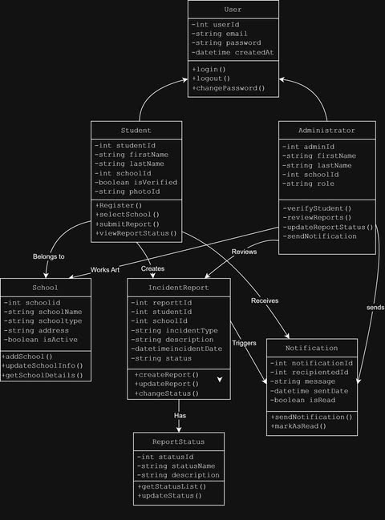**Figure 11. Class Diagram**

The Class Diagram provides a high-level overview of the structure and organization of the Anti-Bullying and Violence Reporting System. It visually represents how different components of the system are related, emphasizing the roles of each user type and how data flows within the system’s architecture.

This diagram demonstrates the relationships between various entities such as users, reports, and administrative functions. It outlines how responsibilities are distributed within the system and how each component interacts with others to carry out tasks such as user authentication, incident reporting, and report management.

By illustrating the logical connections between parts of the system, the class diagram supports a modular and organized design. This helps ensure that the system remains scalable, secure, and easy to maintain. It also guides developers in implementing features that meet the requirements of both students and school administrators within the educational institutions of Poblacion, Daanbantayan, Cebu.

Overall, the class diagram is an essential reference that supports the development process and ensures that the system is built with a clear, structured, and role-based approach.

**Use Case Diagram**

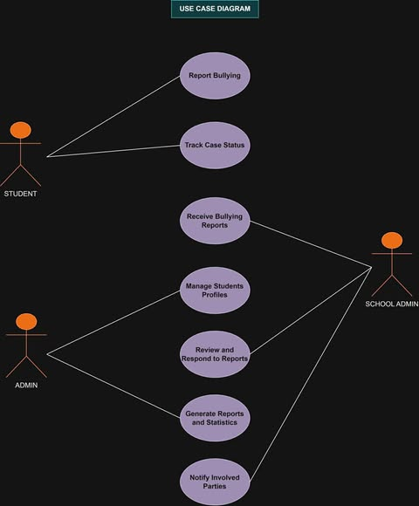

**Figure 12. Use Case Diagram**

This use case diagram illustrates a school bullying reporting system designed to manage bullying incidents effectively. The system involves three key actors: students who can report bullying and track their case status, regular admins who handle day-to-day case management and student profiles, and school admins who oversee the entire process with broader access to reports and statistics. The system provides seven main functions including reporting bullying incidents, tracking case progress, managing student profiles, reviewing and responding to reports, generating analytical reports, and notifying all involved parties. This comprehensive approach ensures proper documentation, accountability, and communication throughout the bullying response process while giving students a safe way to report incidents and administrators the tools they need to address them effectively.

**Sequence Diagram**

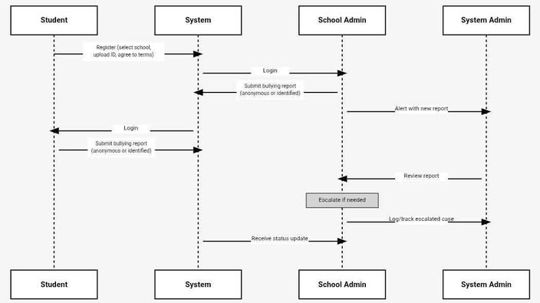**Figure 12: Sequence Diagram**

This sequence diagram illustrates the chronological flow of interactions in a school bullying reporting system, showing how four actors (Student, System, School Admin, and System Admin) communicate over time through message exchanges. The diagram demonstrates the complete process from initial student registration and login through bullying report submission, administrative review, and final status updates, with each vertical dashed line representing an actor's lifeline and horizontal arrows showing the sequence of messages or actions between them.

The diagram captures the systematic workflow where students can register, log in, and submit anonymous or identified bullying reports to the system, which then routes these reports to school administrators for review and resolution.

Once administrators process the reports and decide on appropriate actions, the system provides status updates back to the original reporters, creating a complete feedback loop that ensures transparency and accountability in the bullying incident management process.

**Activity Diagram**

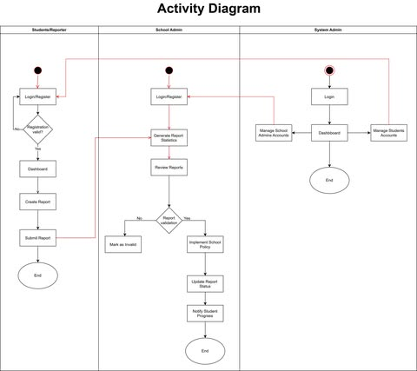

**Figure 13: Activity Diagram**

The **Activity Diagram** outlines the step-by-step workflow of the **SafeSpeak:Anti-Bullying and Violence Reporting System**, showing how users interact with the system from registration to report resolution. It highlights the sequence of actions taken by students and administrators, including key decision points such as account verification and report validation.

This diagram helps visualize the process flow, ensuring clarity in how reports are submitted, processed, and resolved. It supports the system’s goal of providing a structured, efficient, and user-friendly reporting mechanism for schools in **Poblacion, Daanbantayan, Cebu**.

**Development Specifications**

This section outlines the technical and development requirements necessary for the successful implementation of the **SafeSpeak: Anti-Bullying and Violence Reporting System for Public and Private High Schools in Poblacion, Daanbantayan, Cebu**. The system is specifically designed to operate efficiently within educational institutions in both urban and rural school environments, ensuring that it meets the needs of its intended users—students, teachers, and school administrators.

**Software Requirements**

To support the development, deployment, and maintenance of the system, the following software components are required:

* XAMPP – A free and open-source cross-platform web server solution that includes Apache, PHP, and MySQL. It provides the necessary infrastructure to host and run the application on a local or school-based server.
* Web Browser – Any modern browser such as Google Chrome, Mozilla Firefox, or Microsoft Edge, which enables access to the web-based interface.
* Text Editor – Visual Studio Code is recommended for code development due to its integrated debugging tools, syntax highlighting, and ease of use.

**Database Requirements**

* **MySQL** - Comes with XAMPP
* **phpMyAdmin** - Also comes with XAMPP (to manage the database easily)

**Hardware Requirements**

**For the Server (School Computer)**

**Minimum Requirements:**

* A modern personal computer running Windows 10
* At least 4 GB of RAM
* A minimum of 50 GB free disk space
* Stable internet connection

**Recommended Specifications:**

* 8 GB RAM
* 100 GB free space
* High-speed internet connection for optimal performance and availability

**For End Users (Students and Teachers):**

* A functional device such as a smartphone, tablet, laptop, or desktop computer
* Internet connectivity to access the web-based platform
* A compatible web browser to ensure responsive and smooth user interaction

**Programming Environment**

**Front-End Technologies:**

The front-end interface is developed using the following technologies to ensure usability and responsiveness across different devices:

* **HTML –** Used for structuring the web pages and interface elements
* **CSS –** Provides styling and layout consistency throughout the application
* **JavaScript –** Enhances interactivity and dynamic functionality within the user interface
* **Bootstrap –** A responsive front-end framework used to ensure compatibility across various screen sizes and devices

**Simple Structure:**

Website Folder

├── pages/

│ ├── login.html

│ ├── register.html

│ └── report.html

├── css/

│ └── style.css

├── js/

│ └── main.js

└── images/

└── logos/

**Back-End Technologies:**

The back-end functionality is powered by:

* **PHP –** Responsible for processing user requests, handling form submissions, and communicating with the database
* **MySQL –** Stores all application data, including user accounts, incident reports, school lists, and uploaded files

**Simple Structure:**

Backend Folder

├── login.php

├── register.php

├── submit_report.php

├── admin_dashboard.php

└── database/

└── connection.php

**System Design**

The system is designed to support a logical and user-friendly flow that aligns with its core purpose of facilitating anonymous and secure reporting of bullying and violence. The operational flow is as follows:

1. **Student Registration –** A student creates an account, which is then saved in the database.
2. **Incident Reporting –** The student submits a report, including optional file uploads, which is stored securely.
3. **Administrative Notification –** School administrators are notified and can view incoming reports through their dashboard.
4. **Student Feedback –** The student receives status updates confirming that their report has been received and is under review.

**Database Tables**

The system’s database is composed of the following key tables:

* **users –** Contains login credentials and role information for both students and administrators
* **schools –** Stores the list of participating public and private schools in Poblacion, Daanbantayan
* **reports –** Logs all submitted incidents of bullying and violence
* **files –** Maintains records of uploaded files such as images and documents accompanying reports

**Deployment Procedures**

**Local Testing Environment**

To deploy the system for local testing on a development machine:

1. Install the XAMPP package
2. Place the website files into the htdocs directory of the XAMPP installation
3. Launch Apache and MySQL services using the XAMPP control panel
4. Open a web browser and navigate to http://localhost to access the system

**School Server Deployment**

For deployment on an actual school server or hosting environment:

1. Acquire a school-based web hosting solution or configure a dedicated school server
2. Upload all website files and directories to the appropriate server directory
3. Import the project’s database schema and data using phpMyAdmin or command-line MySQL tools
4. Update configuration files to match the server environment (e.g., database credentials, paths)
5. Perform a full system test to ensure all components are functioning as expected

**Testing Phase**

The Testing Phase of the **SafeSpeak: Anti-Bullying and Violence Reporting System for Public and Private High Schools in Poblacion, Daanbantayan, Cebu** is designed to ensure that the system functions accurately, securely, and in accordance with its specified requirements. This phase is critical in validating that both the student-facing and administrative components of the system perform reliably under intended usage scenarios. Although the system has not yet been deployed in a real-world school setting, a comprehensive testing framework has been planned and will be implemented during the development and pre-deployment stages. The testing process will be conducted in multiple phases: Unit Testing, Integration Testing, System Testing, and Acceptance Testing.

**Unit Testing**

Unit testing is concerned with verifying the functionality of individual components of the system in isolation. This includes testing scripts such as register.php, which is responsible for user account creation; login.php, which manages user authentication; and submit_report.php, which handles the submission of anonymous reports along with any attached evidence. Additionally, the database_config.php file will be tested to ensure proper connection between the application and the MySQL database.

These tests will confirm that:

* Students can register using valid school credentials;
* Login attempts are appropriately handled with correct session validation and error notifications;
* Reports and uploaded files are properly stored and associated within the database;
* System components respond correctly when tested in a local server environment using XAMPP and phpMyAdmin.

Each module will be executed and validated individually within the Visual Studio Code and browser-based testing environment to ensure baseline functionality before integration.

**Integration Testing**

Integration testing examines the interaction between the system's individual modules and verifies that data flows smoothly between them. This includes the connection between the student interface, the report submission module, the MySQL database, and the administrative dashboard.

During this phase, the following will be validated:

* A registered user can seamlessly transition to login and access reporting features;
* Submitted reports are accurately stored in the database and properly displayed in the admin dashboard;
* Uploaded images or documents are saved in the designated /uploads/ directory and linked appropriately within the database;
* Administrative users only have access to reports submitted from their respective schools, ensuring data isolation and integrity.

This phase ensures that the system components function cohesively and that transitions between modules occur without disruption.

**System Testing**

System testing involves evaluating the complete and integrated system to ensure that all functionalities operate as expected under real-world conditions. This phase includes testing all major use cases such as account registration, user authentication, incident reporting, report verification, and administrative feedback.

Test cases will be designed to assess:

* The end-to-end student experience, including registration, login, and report submission;
* The administrative review and response process for submitted reports;
* Multi-user access to determine whether the system remains stable during concurrent usage;
* Compatibility and responsiveness across different devices, including smartphones, tablets, and desktop computers;
* Performance benchmarks such as page load time and response accuracy.

The goal of this phase is to confirm that the SafeSpeak system performs reliably as a fully integrated solution and meets the expectations of all user groups.

**Acceptance Testing**

Acceptance testing is the final evaluation phase and involves testing the system in a simulated real-world environment by actual stakeholders. Selected student representatives, teachers, guidance counselors, and school administrators will participate in this phase to validate the system’s functionality and usability based on real-world expectations and needs.

During this phase:

* Users will register and submit sample reports through the system;
* Administrative personnel will access and manage these reports;
* The ease of navigation, accuracy of information, and timeliness of system feedback will be assessed;
* Feedback from users will be collected and analyzed to identify areas of improvement.

This phase aims to ensure that the system aligns with the functional requirements and is ready for deployment in the participating public and private high schools in Poblacion, Daanbantayan, Cebu. Positive feedback from stakeholders will confirm the system’s readiness and its potential to contribute to a safer and more responsive school environment.

**Ethical Considerations**

The development and implementation of the **SafeSpeak: Anti-Bullying and Violence Reporting System for Public and Private High Schools in Poblacion, Daanbantayan, Cebu** requires adherence to rigorous ethical standards to ensure the protection, welfare, and rights of all research participants, particularly minors who constitute the primary user base. This research acknowledges the inherent vulnerabilities of the target population and commits to upholding the highest ethical principles throughout all phases of the study.

**Principle of Beneficence and Non-Maleficence**

This research is guided by the fundamental ethical principle of maximizing benefits while minimizing potential harm to all participants. The primary benefit of the system lies in providing students with secure mechanisms to report bullying incidents, potentially reducing victimization and improving school climate. However, the researchers acknowledge potential risks, including the possibility of retaliation against reporting students, false accusations, and psychological distress resulting from incident disclosure. Comprehensive risk mitigation strategies have been developed to address these concerns, including anonymous reporting options, verification procedures for reports, and immediate support services for affected students.

The research team commits to continuous monitoring of the system's impact on participants and will implement immediate corrective measures if any adverse effects are identified. Regular assessment protocols will evaluate both intended and unintended consequences of system implementation, ensuring that the welfare of participants remains paramount throughout the research process.

**Respect for Persons and Autonomy**

Recognition of the autonomy and dignity of all research participants forms a cornerstone of this study's ethical framework. Students will be treated as individuals capable of making informed decisions about their participation, while acknowledging the developmental considerations and legal protections afforded to minors. The research design incorporates multiple layers of consent, including institutional approval from school administrators, parental or guardian consent for minor participants, and student assent for all users.

Participants will receive comprehensive information about the research objectives, system functionality, data collection procedures, potential risks and benefits, and their rights as research subjects. This information will be presented in age-appropriate language and formats accessible to diverse literacy levels and cultural backgrounds. Students will be explicitly informed of their right to withdraw from the study at any time without penalty or negative consequences to their academic standing or school relationships.

**Justice and Fair Treatment**

The principle of justice requires fair distribution of research benefits and burdens across all participant groups. This study ensures equitable access to the reporting system for all students within the target schools, regardless of socioeconomic status, academic performance, or social standing. The system design accommodates diverse technological capabilities and provides alternative access methods for students with limited internet connectivity or device availability.

Selection criteria for participating schools will be based on objective factors related to research objectives rather than convenience or favorability to researchers. Both public and private institutions will be included to ensure representative sampling and prevent systematic exclusion of particular student populations. The research will provide equal support and training opportunities to all participating institutions, regardless of their existing technological infrastructure or administrative capacity.

**Privacy and Confidentiality Protection**

Given the sensitive nature of bullying incidents and the potential for social stigma or retaliation, this research implements comprehensive privacy protection measures that exceed standard confidentiality requirements. All participant data will be collected, stored, and processed in accordance with applicable data protection laws and institutional policies governing research with human subjects.

Individual student identities will be protected through multiple security layers, including pseudonymization of personal identifiers, encrypted data transmission protocols, and restricted access controls limiting information availability to essential personnel only. The research team will maintain detailed data management protocols specifying procedures for data collection, storage, sharing, and destruction. Participants will be informed about the scope and limitations of confidentiality protections, including circumstances under which disclosure may be legally required.

Long-term data retention policies will balance research needs with privacy protection, ensuring that personally identifiable information is retained only for the minimum period necessary to achieve research objectives and comply with institutional requirements.

**Informed Consent Procedures**

Recognizing the complex consent requirements when conducting research with minor participants, this study implements a comprehensive informed consent framework involving multiple stakeholder groups. School administrators will provide institutional consent for system implementation and research activities within their facilities. Parents or legal guardians will receive detailed information about the research and provide written consent for their children's participation.

Students will participate in age-appropriate assent procedures that explain the research in terms suited to their developmental level and cultural context. The assent process will emphasize voluntary participation, confidentiality protections, and the student's ongoing right to withdraw from the research without consequences. Special attention will be given to ensuring that students understand the difference between the research study and the operational reporting system, clarifying how their participation contributes to system evaluation and improvement.

Consent materials will be available in local languages and will accommodate varying literacy levels through visual aids and verbal explanations as needed. Ongoing consent procedures will allow participants to review and modify their consent decisions as the research progresses.

**Vulnerable Population Protections**

This research recognizes that students involved in bullying incidents, whether as victims, perpetrators, or witnesses, constitute a vulnerable population requiring additional ethical protections. Special safeguards have been implemented to address the unique needs and circumstances of these participants, including immediate access to counseling and support services through school guidance counselors and referral networks.

The research design incorporates trauma-informed approaches that recognize the potential psychological impact of bullying experiences and ensure that research activities do not re-traumatize participants. Procedures for handling disclosures of abuse or imminent danger have been established in coordination with school administrators and local child protection agencies, ensuring that student safety remains the paramount consideration in all research activities.

**Institutional and Regulatory Compliance**

This research will be conducted in full compliance with all applicable institutional, national, and international ethical standards for research involving human subjects. Prior to data collection, the study protocol will be submitted to appropriate institutional review boards or ethics committees for formal approval. All research personnel will complete required training in human subjects protection and maintain current certifications throughout the study period.

The research will adhere to DepEd policies and guidelines governing research activities in educational institutions, including requirements for administrative approval and coordination with school officials. Regular progress reports will be submitted to oversight bodies, and any protocol modifications will be subject to formal review and approval procedures.

**Cultural and Contextual Sensitivity**

Recognition of the cultural context of Poblacion, Daanbantayan, Cebu guides all aspects of this research design and implementation. The research team has consulted with local educators, community leaders, and cultural experts to ensure that research procedures are appropriate and respectful of local values and practices. Particular attention has been given to understanding local concepts of authority, family involvement in school matters, and communication patterns that may influence student willingness to report incidents.

The system design incorporates cultural considerations in interface design, language use, and reporting procedures, ensuring that the technology aligns with local expectations and communication norms while maintaining universal standards for student protection and support.

**Research Integrity and Transparency**

This research commits to maintaining the highest standards of scientific integrity throughout all phases of the study. Data collection, analysis, and reporting procedures will adhere to established methodological standards, and findings will be disseminated accurately and completely regardless of whether they support initial hypotheses or expectations.

Potential conflicts of interest have been identified and will be managed through appropriate disclosure and mitigation procedures. The research team maintains independence from technology vendors or service providers who might benefit commercially from system implementation, ensuring that research findings are not influenced by external commercial interests.

**Ongoing Ethical Review and Adaptation**

Recognizing that ethical considerations may evolve throughout the research process, this study incorporates procedures for ongoing ethical review and adaptation. Regular assessment of ethical compliance will be conducted in consultation with institutional oversight bodies and community stakeholders. Feedback mechanisms allow participants and their families to raise ethical concerns or suggest improvements to research procedures.

The research design maintains flexibility to accommodate emerging ethical considerations or changing circumstances that may affect participant welfare or research validity. Any significant modifications to research procedures will be subject to formal ethical review and approval before implementation, ensuring that participant protections remain current and effective throughout the study period.

**Definition of Terms**

1. **Anti-Bullying:** Refers to actions, policies, and programs designed to prevent, address, and reduce bullying behaviors in school settings, as mandated by Republic Act 10627 and implemented through DepEd policies.
2. **Bullying:** As defined by RA 10627, refers to any severe or repeated use of written, verbal, or electronic expressions, physical acts or gestures, directed at another student that causes physical or emotional harm, creates a hostile environment, or infringes on the rights of others.
3. **Cyberbullying:** Bullying conducted through digital devices and platforms, including social media, messaging apps, gaming platforms, and mobile phones, characterized by persistent harassment, intimidation, or humiliation using electronic means.
4. **Data Analytics:** The process of examining data sets to draw conclusions about the information they contain, particularly patterns, trends, and correlations related to bullying incidents.
5. **DepEd Child Protection Policy:** Department of Education policies and guidelines that establish procedures for protecting children from abuse, violence, exploitation, and discrimination in school settings.
6. **Empowerment:** The process of increasing the capacity of individuals or groups to make choices and transform those choices into desired actions and outcomes, particularly for students to take action against bullying.
7. **Guidance Counselor:** A certified professional in schools responsible for providing counseling services, including receiving and handling bullying reports and coordinating appropriate interventions.
8. **Reporting System:** A structured mechanism that allows individuals to submit information about bullying incidents to appropriate school authorities through digital channels.
9. **School Administrator:** Principals, assistant principals, and other authorized school officials responsible for policy implementation and school management.
10. **User Interface:** The visual component of the reporting system with which users interact, including forms, dashboards, and notification systems.
11. **Violence:** Physical force intended to hurt, injure, or abuse persons or property within the school environment.
12. **Web-based System:** A software application that users access through a web browser over a network such as the internet, requiring no additional software installation on user devices.
13. **Report submission:** Is the act of sending a completed bullying or violence report through the system. This feature ensures that students have a safe and structured way to share their concerns with school authorities.
14. **Incident Report:** Is a detailed account of a bullying or violence case submitted by a student through the system. It contains information about the nature of the incident, the people involved, and any supporting evidence, such as screenshots or photos.
15. **Student Account:** A personalized login provided to each verified student after registration. It allows access to the system's features, such as submitting incident reports or viewing the status of previously filed cases.

**REFERENCES**

Bauman, S., & Del Rio, A. (2006). Preservice teachers' responses to bullying scenarios: Comparing physical, verbal, and relational bullying. Journal of Educational Psychology, 98(1), 219–231. https://doi.org/10.1037/0022-0663.98.1.219

Balingit, M. (2015). Bullying incidents in Philippine schools: An overview. Philippine Journal of Education and Child Welfare, 67(3), 45–56.

Department of Education (DepEd). (2012). Child Protection Policy (DepEd Order No. 40, s. 2012). https://www.deped.gov.ph/2012/05/14/do-40-s-2012-child-protection-policy/

Espelage, D. L., & Swearer, S. M. (2010). A social-ecological model for bullying prevention and intervention: Understanding the impact of adults in the social ecology of youngsters. In S. R. Jimerson, S. M. Swearer, & D. L. Espelage (Eds.), Handbook of bullying in schools: An international perspective (pp. 61–72). Routledge.

Frisén, A., Hasselblad, S., & Holmqvist, K. (2012). The role of digital reporting systems in addressing bullying in schools. Journal of School Violence, 11(4), 335–346. https://doi.org/10.1080/15388220.2012.706738

Hinduja, S., & Patchin, J. W. (2010). Bullying, cyberbullying, and suicide. Archives of Suicide Research, 14(3), 206–221. https://doi.org/10.1080/13811118.2010.494133

Slonje, R., & Smith, P. K. (2008). Cyberbullying: Another main type of bullying? Scandinavian Journal of Psychology, 49(2), 147–154. https://doi.org/10.1111/j.1467-9450.2007.00611.x

Willard, N. (2007). Cyberbullying and cyberthreats: Responding to the challenge of online social aggression, threats, and distress. Research Press.